*EdWest*

## Western Australian Certificate of Education

**Semester 2 Examination, 2018**

##### 

**COMPUTER**

**SCIENCE**

**Unit 1 and 2: Year 11 ATAR**

Source booklet

The information on the following pages will be used to help answer Section Two.

Use the following information to answer Question 21.

TSU pharmaceuticals is a company that conducts research to find a cure for cancer. They have 250 employees and their head office is based in Sydney Australia. Their ICT infrastructure has not been updated for a number of years and they are concerned that a number of their processes are not efficient. They are using hardware that is out of warranty and has started to fail. Their database system is no longer supported by the vendor and their competitors are beginning to get more funding than they are.

To get funds from the government they need to report on their findings each quarter.

Currently their *request for fund system* involves a number of processes which are outlined below.

Firstly, they need to gather the research findings from the scientists. These findings are allocated a number and saved into the research database. The scientists are sent the allocated number for future reference. At the end of the quarter the information is retrieved from the research database and analysed with the current findings. This information is sent to an external consultant who gathers the information and completes the report and funding application. This is sent back to TSU pharmaceuticals to be endorsed and dispatched to the government. Within 4 weeks the government sends them the amount that has been approved.

Use the following information to answer Question 23a.

The following screen shot represents the menu to access the drug test service application.

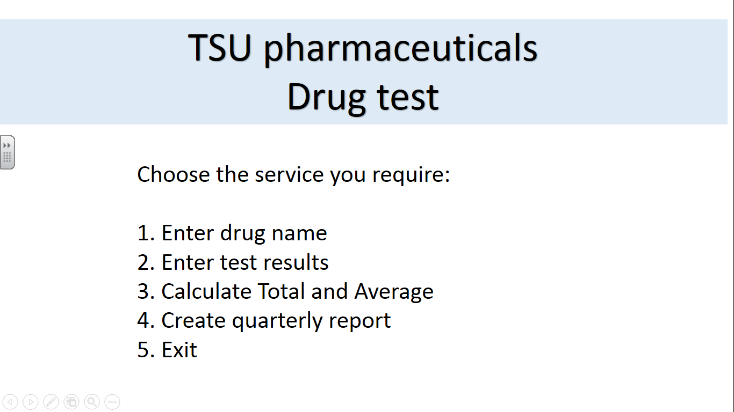

Choices 1 to 4 will run the following procedures: 1 = drugname, 2 = entertest, 3 = calc, 4 = report and 5 = exit.

Use the following information to answer Question 23b.

The information below represents the information required for the *Calculate Total and Average* service that outputs the total and average results for each drug test session.

Initialise *sum* to zero, *min* to 10000, and *max* to zero. Then, enter six results, one by one. For each result, assign it to num and add it to *sum*. At the same time, compare *num* with *min*, if *num* is smaller than *min*, let *min* be *num* instead. Similarly, compare *num* with *max*, if *num* is larger than *max*, let *max* be *num* instead. After all the results have been entered end the loop, divide *sum* by the number of results entered, and assign this to *ave*. Output the *sum* and *ave*.

Use the following information to answer Question 24a.

The table below indicates the present trials, the drugs used, the study phase and the status.

|  |  |  |
| --- | --- | --- |
| Study | Drug(s) | Study Phase |
| Clinicaltrial.gov | Boceprevir  Placebo  Peginterferon alfa B2  Ribavirin | Phase 2 |
| JBH Clinical Trial | Boceprevir  Peginterferon alfa  Ribavirin | Phase 3 |
| ABX Trial | Ribavirin  Boceprevir  Peginterferon alfa | Phase 2 |

Use the following information to answer Question 24b.

Table 1 – Drug selection worksheet named (selection)

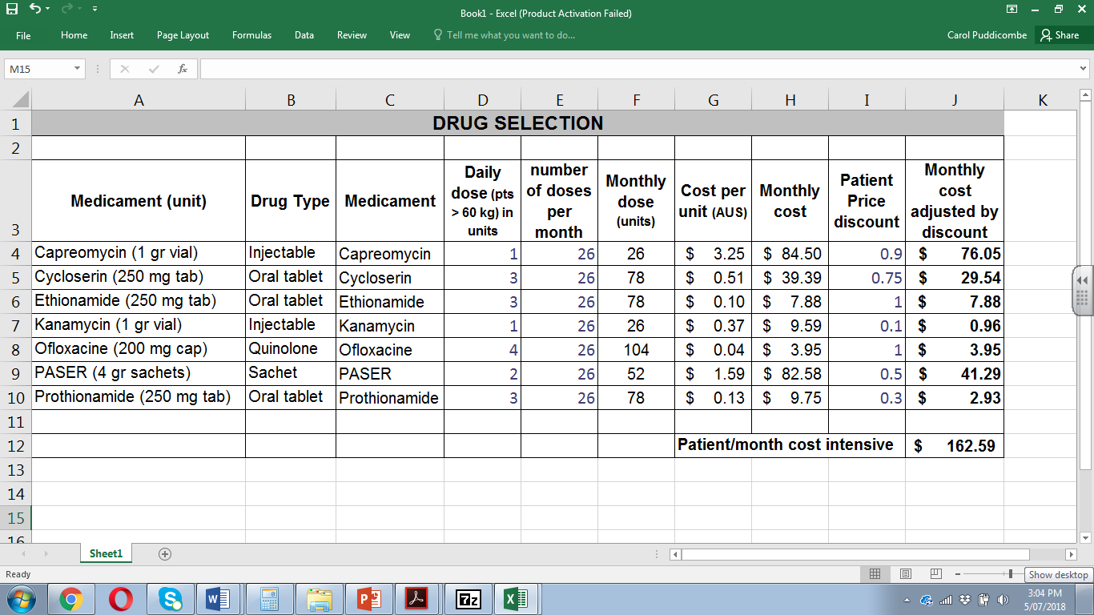

Table 2 – Lookup table worksheet named (lookup)

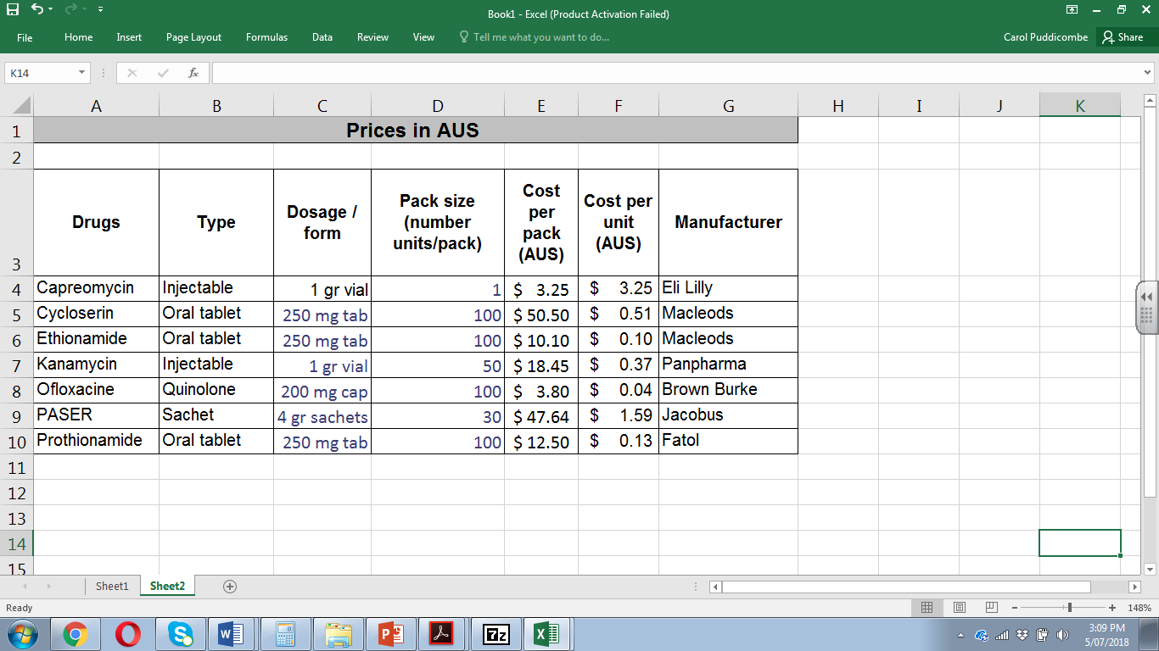

Chart – Monthly cost and Monthly cost adjusted by discount

